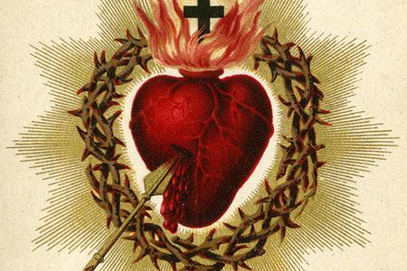Sacred Heart Church

**www.sacredheartniagarafalls.org**

3882 Main St, Niagara Falls, ON L2G 6B6

Constructed 1924

Diocese of St. Catharines

His Excellency, Gerard Bergie, D.D.

Bishop of St. Catharines

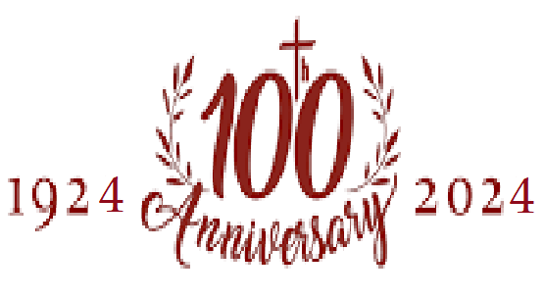

**Liturgical Schedule**

**Mass:** Saturday 5 p.m., Sunday 11 a.m.,

Monday, Tuesday, Wednesday 8 a.m., Thursday 7 p.m., Friday 8 a.m.

**Confessions:** Thirty minutes before each Mass

**Baptisms:** Sundays 12:00 p.m. Contact the parish at least one month in advance. Preparation is required.

**Weddings:** On any day except Sunday. Contact the parish at least six months in advance. Preparation course required.

**Pastor:** Father Stuart MacDonald, JCL

Telephone Email

905-295-4455 [pastor@sacredheartniagarafalls.com](mailto:pastor@sacredheartniagarafalls.com)

**In Residence:** Fr. Jean-Bosco Iyamuremye

**Deacon:** Mr. Anthony Calaycay

**Secretary/Bookkeeper:** Tina Bruzzese

**Office Hours: Tuesdays and Fridays 9 a.m. – 12 p.m.**

[office@sacredheartniagarafalls.com](mailto:office@sacredheartniagarafalls.com)

If you wish to make an online donation, it may be done by e-transfer on your bank’s website using the email address: [donation@sacredheartniagarafalls.com](mailto:donation@sacredheartniagarafalls.com)

**Sunday, June 30, 2024**

**13th Sunday in Ordinary Time**

|  |  |  |
| --- | --- | --- |
| **Mass Schedule** | | |
| Masses at St. Joseph’s  3718 Netherby Road, Stevensville | Intention | Requested by |
| Masses at Sacred Heart |
| Monday, July 1  **CANADA DAY** | 8 a.m.: Gerry & Christine Haymes | John & Julia Mein |
| Tuesday, July 2 | 8 a.m.: Elijah Peter Joseph | Richard & Loretta |
| Wednesday, July 3  **St. Thomas, apostle** | 8 a.m.: +Ida & Clemens van der Zalm | Daryl & Jen Nohara |
| Thursday, July 4 | 7 p.m.: special intention | Gilda Gulla |
| Friday, July 5  First Friday | 8 a.m.:Zbigniew  **8:30: Eucharistic Holy Hour** | John Michael |
| Saturday July 6  St. Maria Goretti  First Saturday | 8 a.m.: +Ron Bryant | friends |
| 5 p.m.: *pro populo* |  |
| Sunday July 7  **14th Sunday in Ordinary Time** | 9 a.m.: Lee & Kathleen Collee | Paul & Mary Jane Collee |
| 11 a.m.: +Silvio Carlesso | Bruno & Lidia Carlesso |
| Monday, July 8 | 8 a.m.: Jessie & Remie Santos | Willie & Josie Mendoza |
| Tuesday, July 9 | 8 a.m.: Anthony & Maria Calaycay | David & Irene Albers |
| Wednesday, July 10 | 8 a.m.: +Bernard LIm | John & Julia Mein |
| Thursday, July 11  St. Benedict | 7 p.m.: Michael Girgenti | Guy &Pat Girgenti |
| Friday, July 12 | 8 a.m.: +Sheila Torscher | Steve Hull |
| Saturday, July 13 | 8 a.m.: **NO MASS** |  |
| 5 p.m.: +Bernard Lim | Richard & Loretta |
| Sunday, July 14  **15th Sunday in Ordinary Time** | 9 a.m.: +Ron Bryant | Frank & Sue Di Bartolomeo |
| 11 a.m.: *pro populo* |  |
| Monday, July 15  St. Bonaventure | 8 a.m.: +Peter Tomasullo | Steve Hull |
| Tuesday, July 16  Our Lady of Mount Carmel | 8 a.m.: special intention | Gilda Gulla |
| Wednesday, July 17 | 8 a.m.: special intentnion | Don & Toni Taddeo |
| Thursday, July 18 | 7 p.m.: Willie Mendoza | Elsie Chang |
| Friday, July 19 | 8 a.m.: +Aurora & Eduardo Santos | Willie & Josie Mendoza |
| Saturday, July 20 | 8 a.m.: Philip Neri Joseph | Richard & Loretta |
| 5 p.m.: Lilian Girgenti | Guy & Pat Girgenti |
| Sunday, July 21  **16th Sunday in Ordinary Time** | 9 a.m.: +Shirley Collee | Melissa Saccone |
| 11 a.m.: *pro populo* |  |
| Monday, July 22  **St. Mary Magdalene** | 8 a.m.: Leon Dupont | Richard & Loretta |
| Tuesday, July 23 | 8 a.m.: +Ron Bryant | Boby & Mary Byrne |
| Wednesday, July 24 | 8 a.m.: +Ron Bryant | Marion Bedard |
| Thursday, July 25  **St. James, apostle** | 7 p.m.: +Arturo Carletti | Bruno & Lidia Carlesso |
| Friday, July 26  **Sts. Anne & Joachim,**  **Parents of the BVM** | 8 a.m.: Bart Di Ciero | Don & Toni Taddeo |
| Saturday, July 27 | 8 a.m.: +Larry Willick | Melissa Saccone |
| 5 p.m.: +Raymond Chang | Elsie Chang |
| Sunday, July 28  **17th Sunday in Ordinary Time** | 9 a.m.: +Clarence Wilcox | Paul & Mary Jane Collee |
| 11 a.m.: *pro populo* |  |

**Weekly Offering**

**June 16: $1235.; June 23: $835.**

All mass intentions, with the exception of 30 that are booked for various future dates, are now fulfilled. Mass intentions are needed.

**Reminder:** Each first Friday of the month there is an eucharistic holy hour beginning after Mass at 8:30 am. The next holy hour is this Friday, July 5. Thank you to Willie & Josie Mendoza and to Trudy Miszk who purchased the new candelabra used for exposition of the Blessed Sacrament. They are a beautiful addition to the sanctuary during our holy hours.

**SAVE THE DATES**

**Sunday, October 27 11 a.m.**

**Sunday, November 10 12 noon**

On October 27, Bishop Bergie will be coming for Mass to celebrate the 100th anniversary of our parish church. During that Mass, the bishop will dedicate the altar and consecrate the church, a beautiful ceremony in which the altar and walls are anointed with Sacred Chrism and incensed as a sign that the building is now permanently set aside as a sacred space dedicated to the worship of God. A reception will follow in the hall. On November 10, we will have a celebratory anniversary luncheon at the Fireman’s Hall. Tickets will be sold for this event. More information will be coming at the end of the summer. In the meantime, **save the dates.**